**CNVnator: An approach to discover genotype  
and characterize typical and atypical CNVs from  
family and population genome sequencing**

This paper has several parts including CNV discovery and genotyping the found genome with specific characterization. As my keen interest is to detect CNV thus this summery deals with the CNV discovery part only of the paper.

As the input of CNVnator it considers RD signal data of the original genotype.

To prepare the RD signal at first what CNVnator does is dividing the genome into non-overlapping same size bin files. Then the count of mapped readings over these bins can consequence to our RD signal. After getting the RD (read-depth) now we partition this signal with the help of mean-shift approach. The bandwidth used in this partitioning plays a vital role as CGH (comparative genomic hybridization) array method is similar to this approach. In this paper a novel method has been introduced to select the bandwidth so that the error in the signal and mapped data get less vulnerability.

The following diagram shows the frequency difference between neighboring RD signals after partitioning the signal in several equal sized bandwidths. 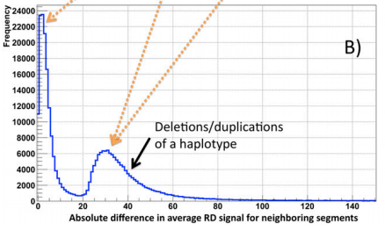

To detect CNVs with their specific locations in the genome is not yet invented. So all we deal with is statistical data. Now we call the CNV function upon the RD signals.

Having same signals in very nearly locations we call them duplications (a variation of copy number). This has some disadvantages like calling upon CNV over same regions multiple times or telling duplications deletions which effects the original reads in a large scale. So avoid such potentials another flagging approach has been introduced called q0 filter.

This CNVnator has also been applied in trio genome samples (that is from father, mother and daughter). This testing results includes significant and more precies CNVs’.